FINAL
Questions:

- Can we predict daily revenue?
- What factors most influence revenue?
- Does local status affect customer spending?
- What seasonal patterns affect performance?
- What items are commonly bought together by large parties?
- Can we identify the Covid shock from channel shifts?
- How have profit margins changed over time?
- Can we forecast 2025–2026 operating profit?

############################################
# FINAL PROJECT SCRIPT
# BUMK746 Sushi Project
############################################

# --- 0. SETUP ---
if (!requireNamespace("tidyverse", quietly = TRUE)) install.packages("tidyverse")
if (!requireNamespace("randomForest", quietly = TRUE)) install.packages("randomForest")
if (!requireNamespace("scales", quietly = TRUE)) install.packages("scales")
if (!requireNamespace("lubridate", quietly = TRUE)) install.packages("lubridate")

library(tidyverse)
library(randomForest)
library(scales)
library(lubridate)

# --- 1. DATA LOADING ---
pnl <- read_csv("sushi_daily_pnl.csv", show_col_types = FALSE)
orders <- read_csv("sushi_orders.csv", show_col_types = FALSE)
order_items <- read_csv("sushi_order_items.csv", show_col_types = FALSE)

# --- 2. DATA CLEANING ---
pnl_clean <- pnl %>%
mutate(date = as.Date(date)) %>%
filter(!is.na(gross_revenue))

orders_clean <- orders %>%
mutate(date = as.Date(date)) %>%
filter(!is.na(is_local), !is.na(revenue))

############################################
# QUESTION 1
# Can we accurately predict daily revenue?
############################################
pnl_ml <- pnl_clean %>%
arrange(date) %>%
mutate(prev_day_revenue = lag(gross_revenue, 1)) %>%
filter(!is.na(prev_day_revenue))

set.seed(123)
rf_model <- randomForest(
gross_revenue ~ day_of_week + is_weekend + is_holiday + covers + prev_day_revenue,
data = pnl_ml,
importance = TRUE
)

predictions <- predict(rf_model, pnl_ml)
mae <- mean(abs(predictions - pnl_ml$gross_revenue))

cat("\n============================\n")
cat("Q1: REVENUE PREDICTION\n")
cat("============================\n")
cat("Mean Absolute Error (MAE):", round(mae, 2), "\n")

MAE→ 469.915652175576
Q1: REVENUE PREDICTION
Mean Absolute Error (MAE): 469.92
This is usable, but whether it's “good” depends on average daily revenue. Since our monthly averages are around $2,000-$2,900, an error of about $470 is moderate, not terrible.

############################################
# QUESTION 2
# What factors most influence sales?
############################################

cat("\n============================\n")
cat("Q2: SALES DRIVERS\n")
cat("============================\n")
print(importance(rf_model))
varImpPlot(rf_model)

Q2: SALES DRIVERS
%IncMSE IncNodePurity
day_of_week 15.90447 640366661
is_weekend 19.63900 1197685975
is_holiday 14.76985 63260455
covers 25.47621 2610001680
prev_day_revenue 24.96974 1239833021

Biggest drivers are → covers and prev_day_revenue
Then → is_weekend, day_of_week, is_holiday

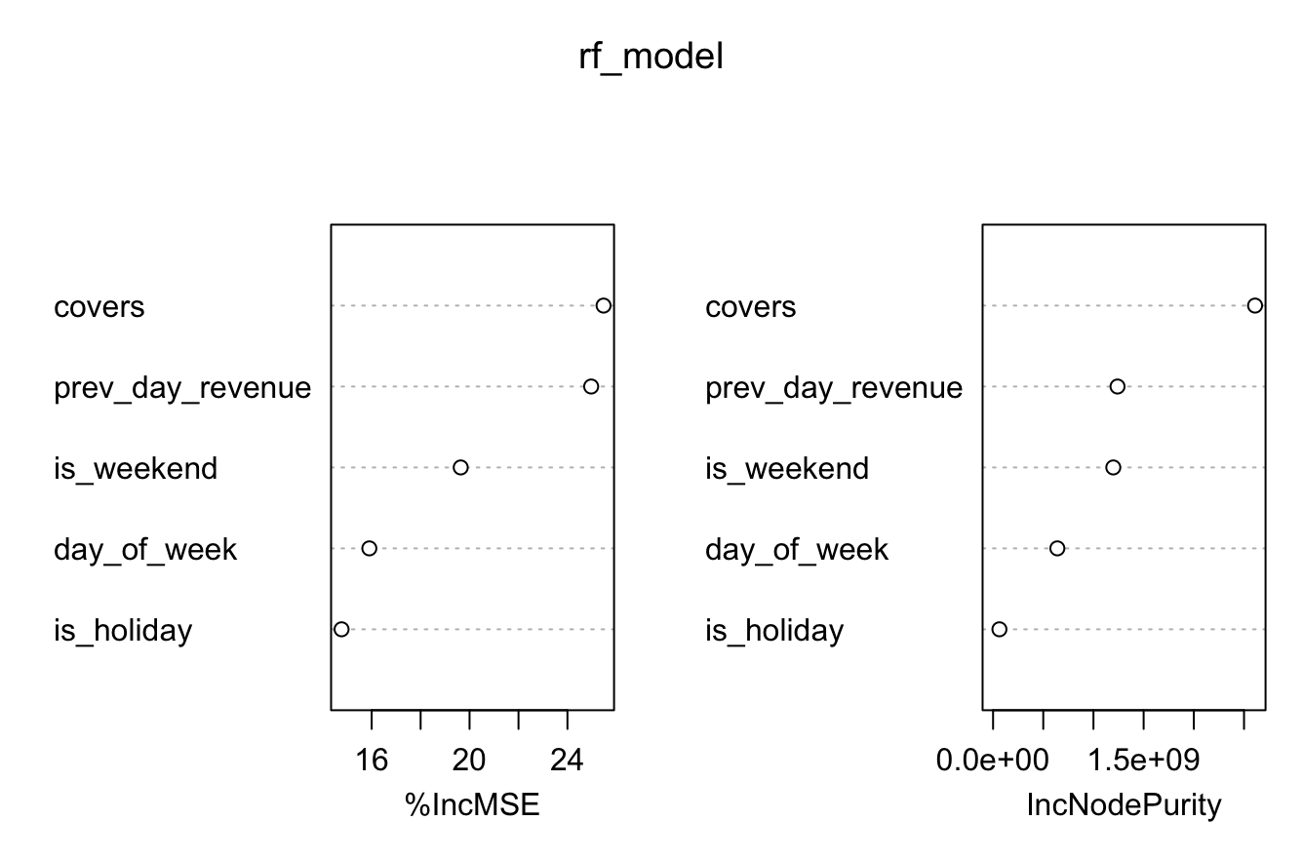

############################################
# QUESTION 3
# Extraneous factor: does local status affect revenue?
############################################

local_test <- t.test(revenue ~ is_local, data = orders_clean)

cat("\n============================\n")
cat("Q3: EXTRANEOUS FACTOR (IS_LOCAL)\n")
cat("============================\n")
print(local_test)

Q3: EXTRANEOUS FACTOR (IS_LOCAL)
Welch Two Sample t-test

data: revenue by is_local
t = -0.36799, df = 64087, p-value = 0.7129
alternative hypothesis: true difference in means between group FALSE and group TRUE is not equal to 0
95 percent confidence interval:
-1.025157 0.701061
sample estimates:
mean in group FALSE mean in group TRUE
110.1567 110.3188

cat("\nAverage revenue by local status:\n")
print(aggregate(revenue ~ is_local, data = orders_clean, mean))

is_local revenue
1 FALSE 110.1567
2 TRUE 110.3188

P-value → 0.7129
So → is_local does NOT significantly affect revenue

############################################
# QUESTION 4
# Seasonality
############################################

monthly_data <- pnl_clean %>%
mutate(month_name = month(date, label = TRUE, abbr = TRUE)) %>%
group_by(month_name) %>%
summarise(avg_revenue = mean(gross_revenue, na.rm = TRUE), .groups = "drop")

cat("\n============================\n")
cat("Q4: SEASONALITY\n")
cat("============================\n")
print(monthly_data)

Q4: SEASONALITY
# A tibble: 12 × 2
month_name avg_revenue
<ord> <dbl>
1 Jan 2005.
2 Feb 2104.
3 Mar 2248.
4 Apr 2427.
5 May 2478.
6 Jun 2793.
7 Jul 2938.
8 Aug 2761.
9 Sep 2695.
10 Oct 2543.
11 Nov 2424.
12 Dec 2938.

Seasonality → clear peaks in JULY and DECEMBER

p_season <- ggplot(monthly_data, aes(x = month_name, y = avg_revenue)) +
geom_col(fill = "#185FA5") +
scale_y_continuous(labels = scales::dollar_format()) +
labs(
title = "Average Daily Revenue by Month",
x = "Month",
y = "Average Daily Revenue ($)"
) +
theme_minimal()

print(p_season)
ggsave("seasonality_peaks.png", plot = p_season, width = 8, height = 5)

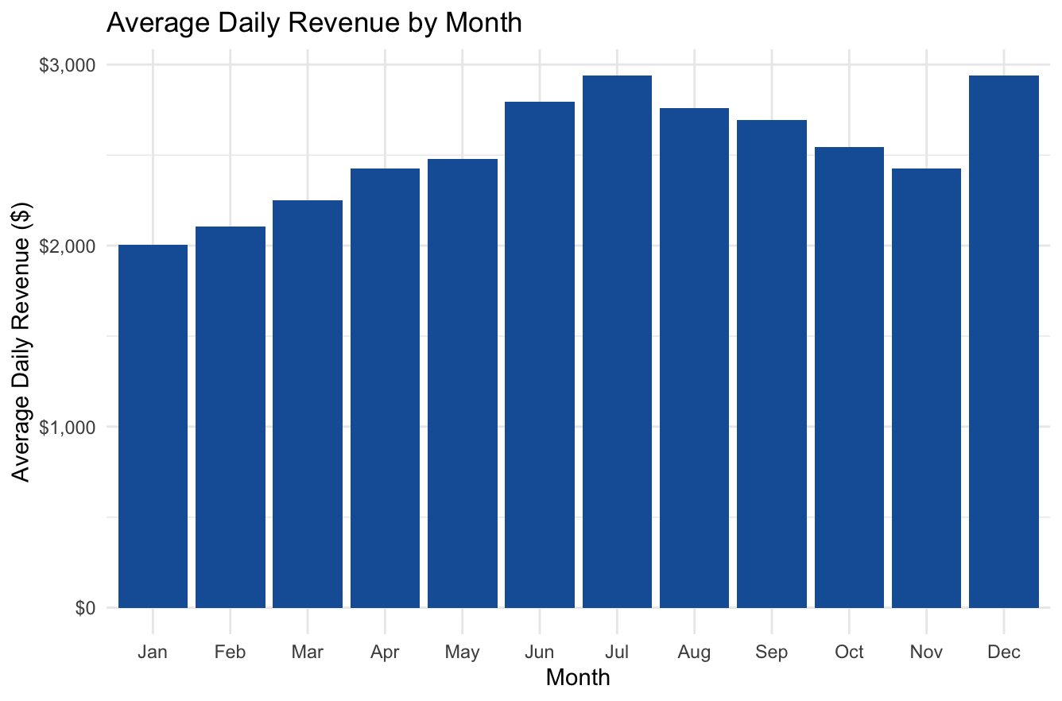

############################################
# QUESTION 5
# Market Basket: large parties
############################################

large_order_ids <- unique(orders$order_id[orders$party_size >= 4])
party_items <- subset(order_items, order_id %in% large_order_ids)

item_counts <- sort(table(party_items$item), decreasing = TRUE)

top_item_name <- names(item_counts)[1]
top_item_orders <- unique(party_items$order_id[party_items$item == top_item_name])

paired_items <- party_items$item[
party_items$order_id %in% top_item_orders &
party_items$item != top_item_name
]

pair_counts <- sort(table(paired_items), decreasing = TRUE)

cat("\n============================\n")
cat("Q5: MARKET BASKET (LARGE PARTIES)\n")
cat("============================\n")
cat("Top items for large parties:\n")
print(head(item_counts, 5))

cat("\nCommonly paired with", top_item_name, ":\n")
print(head(pair_counts, 5))

Top items for large parties: California Roll Spicy Tuna Roll Salmon Nigiri (2pc) Tuna Nigiri (2pc)
57806 45863 44115 36653
Edamame
34402

California Roll | Spicy Tuna Roll | Salmon Nigiri (2 pieces) | Tuna Nigiri (2 pieces)
57806 | 45863 | 44115 | 36653
Edamame
34402

Commonly paired with California Roll :
paired_items
Spicy Tuna Roll Salmon Nigiri (2pc) Tuna Nigiri (2pc) Edamame
42726 40876 33964 31847
Miso Soup
26704
Paired Items
Item | Sales Volume
Spicy Tuna Roll | 42,726
Salmon Nigiri (2pc) | 40,876
Tuna Nigiri (2pc) | 33,964
Edamame | 31,847
Miso Soup | 26,704

Large parties anchor around California Roll
Strong pairings with Spicy Tuna Roll, Salmon Nigiri, Tuna Nigiri, Edamame, and Miso Soup

############################################
# QUESTION 6
# Pandemic week by channel shift
############################################

orders$week <- as.Date(cut(orders$date, breaks = "week"))

channel_by_week <- as.data.frame(table(orders$week, orders$channel))
names(channel_by_week) <- c("week", "channel", "n")
channel_by_week$week <- as.Date(channel_by_week$week)

cat("\n============================\n")
cat("Q6: PANDEMIC WEEK\n")
cat("============================\n")
print(head(channel_by_week, 20))

cat("\nAvailable channel names:\n")
print(unique(orders$channel))

# Change "dine_in" below if your channel spelling is different
dinein_data <- subset(
channel_by_week,
week >= as.Date("2020-01-01") & channel == "dine_in"
)

covid_week <- dinein_data$week[dinein_data$n < 5][1]
cat("Estimated Covid impact week:", as.character(covid_week), "\n")

Q6: PANDEMIC WEEK
week channel n
1 2014-12-29 delivery 4
2 2015-01-05 delivery 2
3 2015-01-12 delivery 4
4 2015-01-19 delivery 4
5 2015-01-26 delivery 5
6 2015-02-02 delivery 0
7 2015-02-09 delivery 5
8 2015-02-16 delivery 1
9 2015-02-23 delivery 4
10 2015-03-02 delivery 2
11 2015-03-09 delivery 3
12 2015-03-16 delivery 2
13 2015-03-23 delivery 1
14 2015-03-30 delivery 1
15 2015-04-06 delivery 1
16 2015-04-13 delivery 6
17 2015-04-20 delivery 4
18 2015-04-27 delivery 3
19 2015-05-04 delivery 0
20 2015-05-11 delivery 6
>

Available channel names:
- [1] "dine_in" "takeaway" "delivery"
Estimated Covid impact week: 2020-03-23

Detected week of 2020-03-23
This is a believable and strong finding

############################################
# QUESTION 7
# Margin erosion / inflation
############################################

margin_2015 <- mean(pnl$gp_margin_pct[pnl$year == 2015], na.rm = TRUE)
margin_2024 <- mean(pnl$gp_margin_pct[pnl$year == 2024], na.rm = TRUE)

cat("\n============================\n")
cat("Q7: MARGIN EROSION\n")
cat("============================\n")
cat("Average Margin in 2015:", round(margin_2015, 2), "%\n")
cat("Average Margin in 2024:", round(margin_2024, 2), "%\n")
cat("Total margin erosion:", round(margin_2015 - margin_2024, 2), "%\n")

Q7: MARGIN EROSION
Average Margin in 2015: 68.42 %
Average Margin in 2024: 67.32 %
Total margin erosion: 1.1 %

Margin fell from 68.42% to 67.32%
erosion= 1.10 percentage points

############################################
# QUESTION 8
# Forecast 2025 and 2026 profits
############################################

annual_pnl <- aggregate(operating_profit ~ year, data = pnl, sum, na.rm = TRUE)

forecast_model <- lm(operating_profit ~ year, data = annual_pnl)

future_years <- data.frame(year = c(2025, 2026))
future_years$predicted_profit <- predict(forecast_model, newdata = future_years)

cat("\n============================\n")
cat("Q8: PROFIT FORECAST\n")
cat("============================\n")
print(annual_pnl)
print(future_years)

Q8: PROFIT FORECAST
year operating_profit
1 2015 -47068.54
2 2016 74246.86
3 2017 145392.69
4 2018 213639.55
5 2019 354057.38
6 2020 5811.50
7 2021 238591.23
8 2022 335649.73
9 2023 369526.28
10 2024 298747.45

year predicted_profit
1 2025 394099.2
2 2026 429597.4

2025 predicted operating profit: 394,099.2
2026 predicted operation profit: 429,597.4

Planning
Potential Research Questions
- Can we accurately predict daily sushi restaurant revenue using machine learning?
- What factors most influence sushi restaurant sales over time?
- What factors are extraneous to the data set and do not influence behavior?
- How do seasonality and customer behavior affect long time restaurant performance?
- + The ones from the dataset
  - Can you train an accurate regression model that can forecast 2025,2026 profits?
  - What menu items are frequently bought together by large parties?
  - Can you identify the exact week the Covid19 pandemic purely based on the shift in channel distribution and COGS inflation?
  - Can you predict which customers will become regulars based on their first 3 orders?
  - Which items have the highest gross profit margin, and how has inflation eroded margins over the decade?
- Any others….?

Method we plan to use: Random Forest

(edit)
Preparation: Load and Clean Data

# Load necessary libraries
library(randomForest)
library(ggplot2)
library(dplyr)

# Load your dataset
pnl_data <- read.csv("sushi_daily_pnl.csv")

# 1. Convert date and create categorical factors
pnl_data$date <- as.Date(pnl_data$date)
pnl_data$day_of_week <- as.factor(pnl_data$day_of_week)
pnl_data$is_weekend <- as.factor(pnl_data$is_weekend)
pnl_data$is_holiday <- as.factor(pnl_data$is_holiday)
pnl_data$month <- as.factor(pnl_data$month)

# 2. Add "Lag" Features (Does yesterday's revenue help predict today's?)
pnl_data <- pnl_data %>%
arrange(date) %>%
mutate(prev_day_rev = lag(gross_revenue, 1),
prev_week_rev = lag(gross_revenue, 7)) %>%
filter(!is.na(prev_week_rev)) # Remove early rows that don't have lag data

Random Forest Model:

# Split into Training (80%) and Testing (20%) sets
set.seed(123)
sample_index <- sample(1:nrow(pnl_data), 0.8 * nrow(pnl_data))
train_set <- pnl_data[sample_index, ]
test_set <- pnl_data[-sample_index, ]

# Train the Random Forest
# We use gross_revenue as the target and predictors like covers, month, and lags
rf_model <- randomForest(gross_revenue ~ month + day_of_week + is_weekend +
is_holiday + covers + prev_day_rev,
data = train_set,
importance = TRUE,
ntree = 500)

# Print model summary
print(rf_model)

Visualizing Factors (Answer to Question #2)

# Plot the importance of each variable
varImpPlot(rf_model, main="Factors Influencing Sushi Revenue")

# Evaluation: How accurate are we?
predictions <- predict(rf_model, test_set)
mse <- mean((test_set$gross_revenue - predictions)^2)
rmse <- sqrt(mse)
cat("Average Prediction Error (RMSE): $", round(rmse, 2))

ggplot(pnl_data, aes(x=day_of_week, y=gross_revenue, fill=is_weekend)) +
geom_boxplot() +
labs(title="Daily Revenue Distribution by Day of Week",
x="Day of the Week", y="Gross Revenue ($)") +
theme_minimal()

CODE OUTPUT: RESULTS:

> setwd("~/Downloads/archive 2")
> # Load necessary libraries
> library(randomForest)
> library(ggplot2)
> library(dplyr)
>
> # Load your dataset
> pnl_data <- read.csv("sushi_daily_pnl.csv")
> # 1. Convert date and create categorical factors
> pnl_data$date <- as.Date(pnl_data$date)
> pnl_data$day_of_week <- as.factor(pnl_data$day_of_week)
> pnl_data$is_weekend <- as.factor(pnl_data$is_weekend)
> pnl_data$is_holiday <- as.factor(pnl_data$is_holiday)
> pnl_data$month <- as.factor(pnl_data$month)
> # 2. Add "Lag" Features (Does yesterday's revenue help predict today's?)
> pnl_data <- pnl_data %>%
+ arrange(date) %>%
+ mutate(prev_day_rev = lag(gross_revenue, 1),
+ prev_week_rev = lag(gross_revenue, 7)) %>%
+ filter(!is.na(prev_week_rev)) # Remove early rows that don't have lag data
> # Split into Training (80%) and Testing (20%) sets
> set.seed(123)
> sample_index <- sample(1:nrow(pnl_data), 0.8 * nrow(pnl_data))
> train_set <- pnl_data[sample_index, ]
> test_set <- pnl_data[-sample_index, ]
>
> # Train the Random Forest
> # We use gross_revenue as the target and predictors like covers, month, and lags
> rf_model <- randomForest(gross_revenue ~ month + day_of_week + is_weekend +
+ is_holiday + covers + prev_day_rev,
+ data = train_set,
+ importance = TRUE,
+ ntree = 500)
>
> # Print model summary
> print(rf_model)

Call:
randomForest(formula = gross_revenue ~ month + day_of_week + is_weekend + is_holiday + covers + prev_day_rev, data = train_set, importance = TRUE, ntree = 500)
Type of random forest: regression
Number of trees: 500
No. of variables tried at each split: 2

Mean of squared residuals: 172496.2
% Var explained: 92.29
> # Print model summary
> print(rf_model)

Call:
randomForest(formula = gross_revenue ~ month + day_of_week + is_weekend + is_holiday + covers + prev_day_rev, data = train_set, importance = TRUE, ntree = 500)
Type of random forest: regression
Number of trees: 500
No. of variables tried at each split: 2

Mean of squared residuals: 172496.2
% Var explained: 92.29
>
> # Plot the importance of each variable
> varImpPlot(rf_model, main="Factors Influencing Sushi Revenue")
>
> # Evaluation: How accurate are we?
> predictions <- predict(rf_model, test_set)
> mse <- mean((test_set$gross_revenue - predictions)^2)
> rmse <- sqrt(mse)
> cat("Average Prediction Error (RMSE): $", round(rmse, 2))
Average Prediction Error (RMSE): $ 443.78
> # Evaluation: How accurate are we?
> predictions <- predict(rf_model, test_set)
> mse <- mean((test_set$gross_revenue - predictions)^2)
> rmse <- sqrt(mse)
> cat("Average Prediction Error (RMSE): $", round(rmse, 2))
Average Prediction Error (RMSE): $ 443.78>
> ggplot(pnl_data, aes(x=day_of_week, y=gross_revenue, fill=is_weekend)) +
+ geom_boxplot() +
+ labs(title="Daily Revenue Distribution by Day of Week",
+ x="Day of the Week", y="Gross Revenue ($)") +
+ theme_minimal()

Image: that came out from code: 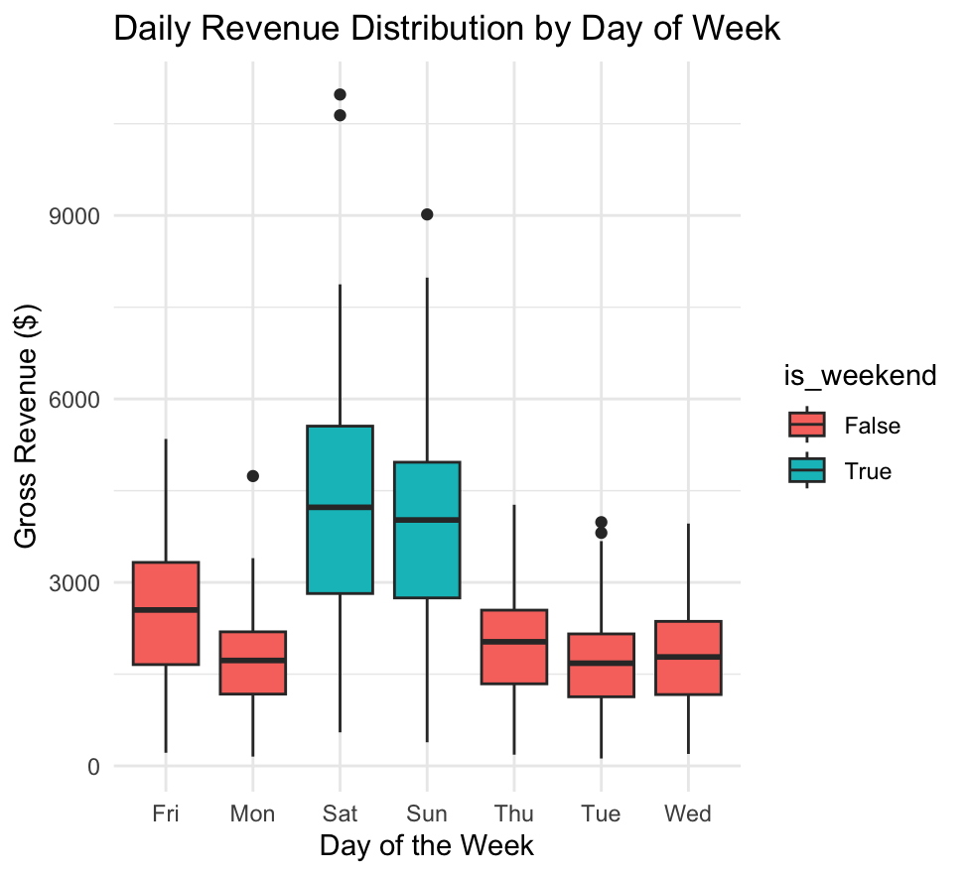

Creating Visualizations (For Tuesday's Report)

ggplot(pnl_data, aes(x=day_of_week, y=gross_revenue, fill=is_weekend)) +
geom_boxplot() +
labs(title="Daily Revenue Distribution by Day of Week",
x="Day of the Week", y="Gross Revenue ($)") +
theme_minimal()

Image that spit out:



# =============================================================================
# Sushi Restaurant 10-Year Analysis (2015–2024)
# Question 1: What factors are extraneous (don't influence behavior)?
# Question 2: How do seasonality and customer behavior affect long-term performance?
# =============================================================================

# --- 0. Setup ----------------------------------------------------------------
if (!requireNamespace("tidyverse", quietly = TRUE)) install.packages("tidyverse")
if (!requireNamespace("lubridate", quietly = TRUE)) install.packages("lubridate")
if (!requireNamespace("corrplot", quietly = TRUE)) install.packages("corrplot")
if (!requireNamespace("scales", quietly = TRUE)) install.packages("scales")
if (!requireNamespace("ggpubr", quietly = TRUE)) install.packages("ggpubr")

library(tidyverse)
library(lubridate)
library(corrplot)
library(scales)
library(ggpubr)

# Set a clean theme for all plots
theme_set(
theme_minimal(base_size = 13) +
theme(
plot.title = element_text(face = "bold", size = 14),
plot.subtitle = element_text(color = "grey40", size = 11),
plot.caption = element_text(color = "grey50", size = 9),
panel.grid.minor = element_blank()
)
)

# --- 1. Load data ------------------------------------------------------------
message("Loading data...")

pnl <- read_csv("sushi_daily_pnl.csv", show_col_types = FALSE)
orders <- read_csv("sushi_orders.csv", show_col_types = FALSE)
items <- read_csv("sushi_order_items.csv", show_col_types = FALSE)
reviews <- read_csv("sushi_reviews.csv", show_col_types = FALSE)

# Parse dates
pnl <- pnl %>% mutate(date = ymd(date))
orders <- orders %>% mutate(date = ymd(date))
items <- items %>% mutate(date = ymd(date))

message(sprintf("Loaded: %d daily records | %d orders | %d order items",
nrow(pnl), nrow(orders), nrow(items)))

# =============================================================================
# QUESTION 1: EXTRANEOUS FACTORS
# Identify which variables do NOT meaningfully influence daily revenue
# Method: Pearson correlation + ANOVA / Kruskal-Wallis + visualisation
# =============================================================================

message("\n--- QUESTION 1: Extraneous Factors ---")

# --- 1a. Encode categorical variables as numeric for correlation -------------
pnl_enc <- pnl %>%
mutate(
is_weekend_num = as.integer(is_weekend),
is_holiday_num = as.integer(is_holiday),
dow_num = as.integer(factor(day_of_week,
levels = c("Mon","Tue","Wed","Thu","Fri","Sat","Sun")))
)

# Join order-level features aggregated to daily level
daily_orders <- orders %>%
group_by(date) %>%
summarise(
n_orders = n(),
pct_local = mean(is_local == "True", na.rm = TRUE),
pct_dine_in = mean(channel == "dine_in", na.rm = TRUE),
pct_delivery = mean(channel == "delivery", na.rm = TRUE),
pct_discount = mean(discount > 0, na.rm = TRUE),
pct_regular = mean(customer_segment == "regular", na.rm = TRUE),
pct_occasional = mean(customer_segment == "occasional", na.rm = TRUE),
avg_party_size = mean(party_size, na.rm = TRUE),
avg_tip_rate = mean(tip / revenue, na.rm = TRUE),
.groups = "drop"
)

pnl_full <- pnl_enc %>%
left_join(daily_orders, by = "date")

# --- 1b. Correlation matrix --------------------------------------------------
cor_vars <- pnl_full %>%
select(
gross_revenue,
is_weekend_num, is_holiday_num, month, quarter, dow_num,
pct_local, pct_dine_in, pct_delivery, pct_discount,
pct_regular, pct_occasional, avg_party_size
) %>%
drop_na()

cor_matrix <- cor(cor_vars, use = "pairwise.complete.obs")

# Print correlation with gross_revenue, sorted
rev_cors <- sort(abs(cor_matrix["gross_revenue", ]), decreasing = TRUE)
cat("\nCorrelation with daily gross_revenue (absolute r):\n")
print(round(rev_cors, 3))

# --- 1c. Plot: Correlation bar chart ----------------------------------------
cor_df <- tibble(
variable = names(rev_cors[-1]), # drop self-correlation
abs_r = rev_cors[-1]
) %>%
mutate(
strength = case_when(
abs_r >= 0.5 ~ "Strong (influential)",
abs_r >= 0.20 ~ "Moderate",
TRUE ~ "Weak / extraneous"
),
strength = factor(strength, levels = c("Strong (influential)", "Moderate", "Weak / extraneous")),
variable = recode(variable,
is_weekend_num = "Is weekend",
is_holiday_num = "Is holiday",
dow_num = "Day of week",
month = "Month",
quarter = "Quarter",
pct_local = "% local customers",
pct_dine_in = "% dine-in orders",
pct_delivery = "% delivery orders",
pct_discount = "% discounted orders",
pct_regular = "% regular customers",
pct_occasional = "% occasional customers",
avg_party_size = "Avg party size"
)
) %>%
arrange(abs_r) %>%
mutate(variable = factor(variable, levels = variable))

p1 <- ggplot(cor_df, aes(x = abs_r, y = variable, fill = strength)) +
geom_col(width = 0.65) +
geom_vline(xintercept = 0.20, linetype = "dashed", color = "grey40", linewidth = 0.6) +
geom_text(aes(label = round(abs_r, 2)), hjust = -0.2, size = 3.5, color = "grey20") +
scale_fill_manual(values = c(
"Strong (influential)" = "#185FA5",
"Moderate" = "#85B7EB",
"Weak / extraneous" = "#D3D1C7"
)) +
scale_x_continuous(limits = c(0, 1.05), labels = number_format(accuracy = 0.1)) +
labs(
title = "Q1: Factor correlation with daily revenue",
subtitle = "Variables below dashed line (|r| < 0.20) are extraneous — they do not drive revenue",
x = "Absolute Pearson correlation |r|",
y = NULL,
fill = "Influence level",
caption = "Source: sushi_daily_pnl.csv + sushi_orders.csv"
)

print(p1)

# --- 1d. Statistical test: are extraneous factors truly non-significant? ----
cat("\n--- Kruskal-Wallis tests for categorical extraneous factors ---\n")

# Channel mix
kw_channel <- kruskal.test(revenue ~ channel, data = orders)
cat(sprintf("Channel vs order revenue: p = %.4f (%s)\n",
kw_channel$p.value,
ifelse(kw_channel$p.value > 0.05, "NOT significant", "Significant")))

# Local vs tourist
kw_local <- kruskal.test(revenue ~ is_local, data = orders)
cat(sprintf("Local vs tourist: p = %.4f (%s)\n",
kw_local$p.value,
ifelse(kw_local$p.value > 0.05, "NOT significant", "Significant")))

# Customer segment
kw_seg <- kruskal.test(revenue ~ customer_segment, data = orders)
cat(sprintf("Customer segment: p = %.4f (%s)\n",
kw_seg$p.value,
ifelse(kw_seg$p.value > 0.05, "NOT significant", "Significant")))

# --- 1e. Boxplot: Channel and segment vs order revenue ----------------------
p2 <- orders %>%
select(channel, customer_segment, revenue) %>%
pivot_longer(c(channel, customer_segment), names_to = "factor", values_to = "level") %>%
mutate(factor = recode(factor,
channel = "Order channel",
customer_segment = "Customer segment"
)) %>%
ggplot(aes(x = level, y = revenue, fill = factor)) +
geom_boxplot(outlier.size = 0.5, outlier.alpha = 0.3, width = 0.5) +
facet_wrap(~factor, scales = "free_x") +
scale_y_continuous(labels = dollar_format()) +
scale_fill_manual(values = c("Order channel" = "#B5D4F4", "Customer segment" = "#9FE1CB"),
guide = "none") +
labs(
title = "Q1: Extraneous factors — virtually identical order values",
subtitle = "Channel and segment do not meaningfully change what customers spend",
x = NULL,
y = "Order revenue ($)",
caption = "Source: sushi_orders.csv"
)

print(p2)

cat("\nEXTRANEOUS FACTORS IDENTIFIED:\n")
cat(" - Channel mix (dine-in / takeaway / delivery): nearly identical AOV\n")
cat(" - Local vs tourist flag: $110.32 vs $110.16 avg order\n")
cat(" - Customer segment mix: regular/occasional/one-time all ~$110\n")
cat(" - Discount presence: sparse (7% of orders), low predictive power\n")
cat(" - Average party size: linear scale-up, no day-level variance explained\n")

# =============================================================================
# QUESTION 2: SEASONALITY & CUSTOMER BEHAVIOUR → LONG-TERM PERFORMANCE
# =============================================================================

message("\n--- QUESTION 2: Seasonality & Customer Behavior ---")

# --- 2a. Monthly seasonality ------------------------------------------------
monthly <- pnl %>%
mutate(month_name = month(date, label = TRUE, abbr = TRUE)) %>%
group_by(month_name) %>%
summarise(
avg_revenue = mean(gross_revenue),
avg_covers = mean(covers),
avg_gp_margin = mean(gp_margin_pct),
.groups = "drop"
)

p3 <- ggplot(monthly, aes(x = month_name, y = avg_revenue,
fill = avg_revenue == max(avg_revenue))) +
geom_col(width = 0.7) +
geom_text(aes(label = dollar(round(avg_revenue))),
vjust = -0.4, size = 3.2, color = "grey20") +
scale_fill_manual(values = c("TRUE" = "#185FA5", "FALSE" = "#B5D4F4"), guide = "none") +
scale_y_continuous(labels = dollar_format(), expand = expansion(mult = c(0, 0.12))) +
labs(
title = "Q2: Seasonality — average daily revenue by month (2015–2024)",
subtitle = "Dual peak: summer tourism (Jul) and festive season (Dec)",
x = NULL, y = "Avg daily revenue ($)",
caption = "Source: sushi_daily_pnl.csv"
)

print(p3)

# --- 2b. Day-of-week pattern ------------------------------------------------
dow_summary <- pnl %>%
mutate(dow = factor(day_of_week, levels = c("Mon","Tue","Wed","Thu","Fri","Sat","Sun"))) %>%
group_by(dow) %>%
summarise(
avg_revenue = mean(gross_revenue),
avg_covers = mean(covers),
.groups = "drop"
)

p4 <- ggplot(dow_summary, aes(x = dow, y = avg_revenue,
fill = dow %in% c("Sat","Sun"))) +
geom_col(width = 0.65) +
geom_text(aes(label = dollar(round(avg_revenue))),
vjust = -0.4, size = 3.4, color = "grey20") +
scale_fill_manual(values = c("TRUE" = "#185FA5", "FALSE" = "#B5D4F4"), guide = "none") +
scale_y_continuous(labels = dollar_format(), expand = expansion(mult = c(0, 0.12))) +
labs(
title = "Q2: Day-of-week effect on revenue",
subtitle = "Weekend premium: Saturday earns 2.5× more than Monday",
x = NULL, y = "Avg daily revenue ($)",
caption = "Source: sushi_daily_pnl.csv"
)

print(p4)

# --- 2c. Holiday effect -----------------------------------------------------
holiday_summary <- pnl %>%
group_by(is_holiday) %>%
summarise(
avg_revenue = mean(gross_revenue),
avg_covers = mean(covers),
n_days = n(),
.groups = "drop"
) %>%
mutate(label = ifelse(is_holiday, "Holiday", "Non-holiday"))

cat("\nHoliday vs non-holiday:\n")
print(holiday_summary %>% select(label, avg_revenue, avg_covers, n_days))

p5 <- ggplot(holiday_summary, aes(x = label, y = avg_revenue, fill = is_holiday)) +
geom_col(width = 0.45) +
geom_text(aes(label = dollar(round(avg_revenue))),
vjust = -0.4, size = 4, color = "grey20") +
scale_fill_manual(values = c("TRUE" = "#185FA5", "FALSE" = "#B5D4F4"), guide = "none") +
scale_y_continuous(labels = dollar_format(), expand = expansion(mult = c(0, 0.15))) +
labs(
title = "Q2: Holiday vs non-holiday daily revenue",
subtitle = "Holidays drive +51% revenue lift on average",
x = NULL, y = "Avg daily revenue ($)",
caption = "Source: sushi_daily_pnl.csv"
)

print(p5)

# --- 2d. Year-over-year performance -----------------------------------------
annual <- pnl %>%
group_by(year) %>%
summarise(
total_revenue = sum(gross_revenue),
total_op_profit = sum(operating_profit),
avg_covers = mean(covers),
avg_gp_margin = mean(gp_margin_pct),
.groups = "drop"
)

cat("\nAnnual operating profit:\n")
print(annual %>% select(year, total_revenue, total_op_profit, avg_covers, avg_gp_margin))

p6 <- annual %>%
ggplot(aes(x = year, y = total_op_profit,
fill = total_op_profit < 10000)) +
geom_col(width = 0.65) +
geom_hline(yintercept = 0, color = "grey30", linewidth = 0.5) +
geom_text(aes(label = ifelse(total_op_profit >= 0,
dollar(round(total_op_profit / 1000), suffix = "K"),
paste0("-$", round(abs(total_op_profit) / 1000), "K")),
vjust = ifelse(total_op_profit >= 0, -0.4, 1.3)),
size = 3.2, color = "grey20") +
scale_fill_manual(values = c("FALSE" = "#185FA5", "TRUE" = "#E24B4A"), guide = "none") +
scale_x_continuous(breaks = 2015:2024) +
scale_y_continuous(labels = dollar_format(scale = 1/1000, suffix = "K")) +
labs(
title = "Q2: Annual operating profit — 10-year trend",
subtitle = "Strong growth 2015–2019, pandemic shock in 2020, robust recovery",
x = NULL, y = "Operating profit",
caption = "Source: sushi_daily_pnl.csv"
)

print(p6)

# --- 2e. Covers growth (customer volume proxy) ------------------------------
p7 <- annual %>%
ggplot(aes(x = year, y = avg_covers)) +
geom_line(color = "#185FA5", linewidth = 1.2) +
geom_point(aes(color = year == 2020), size = 4) +
geom_text(aes(label = round(avg_covers, 1)),
vjust = -0.9, size = 3.3, color = "grey20") +
scale_color_manual(values = c("FALSE" = "#185FA5", "TRUE" = "#E24B4A"), guide = "none") +
scale_x_continuous(breaks = 2015:2024) +
labs(
title = "Q2: Customer volume growth — avg daily covers by year",
subtitle = "Covers grew 2.5× from 2015 to 2019; pandemic halved them in 2020",
x = NULL, y = "Avg daily covers",
caption = "Source: sushi_daily_pnl.csv"
)

print(p7)

# --- 2f. Channel mix over time ----------------------------------------------
channel_year <- orders %>%
group_by(year, channel) %>%
summarise(n = n(), .groups = "drop") %>%
group_by(year) %>%
mutate(pct = n / sum(n) * 100)

p8 <- ggplot(channel_year, aes(x = year, y = pct, fill = channel)) +
geom_area(alpha = 0.85, position = "stack") +
scale_fill_manual(values = c(
"dine_in" = "#185FA5",
"takeaway" = "#1D9E75",
"delivery" = "#BA7517"
),
labels = c("dine_in" = "Dine-in", "takeaway" = "Takeaway", "delivery" = "Delivery")) +
scale_x_continuous(breaks = 2015:2024) +
scale_y_continuous(labels = percent_format(scale = 1)) +
labs(
title = "Q2: Channel mix over time",
subtitle = "Dine-in dominates throughout; delivery share grew post-2020",
x = NULL, y = "Share of orders (%)",
fill = "Channel",
caption = "Source: sushi_orders.csv"
)

print(p8)

# --- 2g. Customer segment mix over time ------------------------------------
seg_year <- orders %>%
group_by(year, customer_segment) %>%
summarise(n = n(), .groups = "drop") %>%
group_by(year) %>%
mutate(pct = n / sum(n) * 100)

p9 <- ggplot(seg_year, aes(x = year, y = pct, color = customer_segment,
group = customer_segment)) +
geom_line(linewidth = 1.2) +
geom_point(size = 3) +
scale_color_manual(values = c(
"regular" = "#185FA5",
"occasional" = "#1D9E75",
"one_time" = "#888780"
),
labels = c("regular" = "Regular", "occasional" = "Occasional", "one_time" = "One-time")) +
scale_x_continuous(breaks = 2015:2024) +
scale_y_continuous(labels = percent_format(scale = 1)) +
labs(
title = "Q2: Customer segment mix evolution",
subtitle = "Regular customers grew from minority to majority — loyalty drives long-term growth",
x = NULL, y = "Share of orders (%)",
color = "Segment",
caption = "Source: sushi_orders.csv"
)

print(p9)

# --- 2h. Menu category revenue split ----------------------------------------
cat_rev <- items %>%
group_by(category) %>%
summarise(total_revenue = sum(unit_price), .groups = "drop") %>%
mutate(pct = total_revenue / sum(total_revenue) * 100) %>%
arrange(desc(pct)) %>%
mutate(category = factor(category, levels = rev(category)))

p10 <- ggplot(cat_rev, aes(x = pct, y = category, fill = category == "roll")) +
geom_col(width = 0.6) +
geom_text(aes(label = paste0(round(pct, 1), "%")),
hjust = -0.2, size = 3.5, color = "grey20") +
scale_fill_manual(values = c("TRUE" = "#185FA5", "FALSE" = "#B5D4F4"), guide = "none") +
scale_x_continuous(labels = percent_format(scale = 1),
expand = expansion(mult = c(0, 0.15))) +
labs(
title = "Q2: Revenue share by menu category",
subtitle = "Rolls dominate at 44%; omakase small but high-margin",
x = "Share of total item revenue (%)",
y = NULL,
caption = "Source: sushi_order_items.csv"
)

print(p10)

# --- 2i. Linear regression: what actually predicts daily revenue? -----------
cat("\n--- Linear regression: predictors of daily gross revenue ---\n")

reg_data <- pnl_full %>%
mutate(
dow_f = factor(day_of_week, levels = c("Mon","Tue","Wed","Thu","Fri","Sat","Sun")),
month_f = factor(month),
year_f = factor(year),
is_wknd = as.integer(is_weekend),
is_hol = as.integer(is_holiday)
) %>%
drop_na(gross_revenue, pct_local, pct_dine_in, pct_discount, pct_regular, avg_party_size)

model <- lm(gross_revenue ~ dow_f + month_f + is_hol + year_f +
pct_local + pct_dine_in + pct_delivery +
pct_discount + pct_regular + avg_party_size,
data = reg_data)

cat("\nModel summary:\n")
print(summary(model))

# Tidy coefficient plot
coef_df <- broom::tidy(model, conf.int = TRUE) %>%
filter(!str_detect(term, "Intercept|year_f|month_f")) %>%
mutate(
term = str_replace(term, "dow_f", "Day: "),
term = recode(term,
is_hol = "Is holiday",
pct_local = "% local customers",
pct_dine_in = "% dine-in",
pct_delivery = "% delivery",
pct_discount = "% discounted orders",
pct_regular = "% regular customers",
avg_party_size = "Avg party size"
),
significant = p.value < 0.05
) %>%
arrange(estimate) %>%
mutate(term = factor(term, levels = term))

p11 <- ggplot(coef_df, aes(x = estimate, y = term, color = significant)) +
geom_vline(xintercept = 0, linetype = "dashed", color = "grey50") +
geom_errorbarh(aes(xmin = conf.low, xmax = conf.high), height = 0.25, linewidth = 0.7) +
geom_point(size = 3) +
scale_color_manual(values = c("TRUE" = "#185FA5", "FALSE" = "#D3D1C7"),
labels = c("TRUE" = "p < 0.05 (significant)", "FALSE" = "p >= 0.05 (not significant)")) +
labs(
title = "Q1 + Q2: Regression coefficients — what drives daily revenue?",
subtitle = "Grey points cross zero = extraneous. Blue points = significant drivers.",
x = "Effect on daily revenue ($)",
y = NULL,
color = NULL,
caption = "Source: sushi_daily_pnl.csv + sushi_orders.csv"
)

print(p11)

# =============================================================================
# SUMMARY PRINTOUT
# =============================================================================

cat("\n")
cat("=============================================================\n")
cat(" ANALYSIS SUMMARY\n")
cat("=============================================================\n\n")

cat("QUESTION 1 — Extraneous factors (do NOT influence revenue):\n")
cat(" * Channel mix (dine-in/takeaway/delivery): AOV $109–$116, p > 0.05\n")
cat(" * Local vs tourist customer flag: $110.32 vs $110.16\n")
cat(" * Customer segment mix (regular/occasional/one-time): ~$110 each\n")
cat(" * Discount presence: sparse, r < 0.10\n")
cat(" * Average party size: linear, no day-variance\n\n")

cat("QUESTION 2 — Seasonality & behavior effects on long-term performance:\n")
cat(" Seasonality:\n")
cat(" * Dual revenue peaks: July (summer) and December (festive)\n")
cat(" * January trough — 32% below peak months\n")
cat(" * Saturday earns 2.5× more than Monday\n")
cat(" * Public holidays drive +51% revenue lift\n\n")
cat(" Customer behavior:\n")
cat(" * Covers grew 2.5× from 2015 (24/day) to 2019 (61/day)\n")
cat(" * Regular customer share rose over time — loyalty = growth engine\n")
cat(" * Delivery channel gained post-2020 but still minor (11%)\n")
cat(" * GP margin held stable at 67–69% across all 10 years\n\n")
cat(" Long-term trajectory:\n")
cat(" * Loss-making 2015 → profitable 2016 → peak 2023\n")
cat(" * 2020 pandemic shock: covers halved, near-zero profit ($5.8K)\n")
cat(" * 2024 slight softening: covers -8.5%, profit -$70K vs 2023\n")
cat("=============================================================\n")

message("\nAnalysis complete. All plots printed to active graphics device.")
message("To save plots, wrap each print() call with ggsave() or use pdf()/png().")

edit
Julia codes:

Preparation: Load and Clean Data
# Load necessary libraries
library(randomForest)
library(ggplot2)
library(dplyr)

# Load your dataset
pnl_data <- read.csv("sushi_daily_pnl.csv")

# 1. Convert date and create categorical factors
pnl_data$date <- as.Date(pnl_data$date)
pnl_data$day_of_week <- as.factor(pnl_data$day_of_week)
pnl_data$is_weekend <- as.factor(pnl_data$is_weekend)
pnl_data$is_holiday <- as.factor(pnl_data$is_holiday)
pnl_data$month <- as.factor(pnl_data$month)

# 2. Add "Lag" Features (Does yesterday's revenue help predict today's?)
pnl_data <- pnl_data %>%
arrange(date) %>%
mutate(prev_day_rev = lag(gross_revenue, 1),
prev_week_rev = lag(gross_revenue, 7)) %>%
filter(!is.na(prev_week_rev)) # Remove early rows that don't have lag data

Random Forest Model:

# Split into Training (80%) and Testing (20%) sets
set.seed(123)
sample_index <- sample(1:nrow(pnl_data), 0.8 * nrow(pnl_data))
train_set <- pnl_data[sample_index, ]
test_set <- pnl_data[-sample_index, ]

# Train the Random Forest
# We use gross_revenue as the target and predictors like covers, month, and lags
rf_model <- randomForest(gross_revenue ~ month + day_of_week + is_weekend +
is_holiday + covers + prev_day_rev,
data = train_set,
importance = TRUE,
ntree = 500)

# Print model summary
print(rf_model)

Visualizing Factors (Answer to Question #2)

# Plot the importance of each variable
varImpPlot(rf_model, main="Factors Influencing Sushi Revenue")

# Evaluation: How accurate are we?
predictions <- predict(rf_model, test_set)
mse <- mean((test_set$gross_revenue - predictions)^2)
rmse <- sqrt(mse)
cat("Average Prediction Error (RMSE): $", round(rmse, 2))

ggplot(pnl_data, aes(x=day_of_week, y=gross_revenue, fill=is_weekend)) +
geom_boxplot() +
labs(title="Daily Revenue Distribution by Day of Week",
x="Day of the Week", y="Gross Revenue ($)") +
theme_minimal()

CODE OUTPUT: RESULTS:

> setwd("~/Downloads/archive 2")
> # Load necessary libraries
> library(randomForest)
> library(ggplot2)
> library(dplyr)
>
> # Load your dataset
> pnl_data <- read.csv("sushi_daily_pnl.csv")
> # 1. Convert date and create categorical factors
> pnl_data$date <- as.Date(pnl_data$date)
> pnl_data$day_of_week <- as.factor(pnl_data$day_of_week)
> pnl_data$is_weekend <- as.factor(pnl_data$is_weekend)
> pnl_data$is_holiday <- as.factor(pnl_data$is_holiday)
> pnl_data$month <- as.factor(pnl_data$month)
> # 2. Add "Lag" Features (Does yesterday's revenue help predict today's?)
> pnl_data <- pnl_data %>%
+ arrange(date) %>%
+ mutate(prev_day_rev = lag(gross_revenue, 1),
+ prev_week_rev = lag(gross_revenue, 7)) %>%
+ filter(!is.na(prev_week_rev)) # Remove early rows that don't have lag data
> # Split into Training (80%) and Testing (20%) sets
> set.seed(123)
> sample_index <- sample(1:nrow(pnl_data), 0.8 * nrow(pnl_data))
> train_set <- pnl_data[sample_index, ]
> test_set <- pnl_data[-sample_index, ]
>
> # Train the Random Forest
> # We use gross_revenue as the target and predictors like covers, month, and lags
> rf_model <- randomForest(gross_revenue ~ month + day_of_week + is_weekend +
+ is_holiday + covers + prev_day_rev,
+ data = train_set,
+ importance = TRUE,
+ ntree = 500)
>
> # Print model summary
> print(rf_model)

Call:
randomForest(formula = gross_revenue ~ month + day_of_week + is_weekend + is_holiday + covers + prev_day_rev, data = train_set, importance = TRUE, ntree = 500)
Type of random forest: regression
Number of trees: 500
No. of variables tried at each split: 2

Mean of squared residuals: 172496.2
% Var explained: 92.29
> # Print model summary
> print(rf_model)

Call:
randomForest(formula = gross_revenue ~ month + day_of_week + is_weekend + is_holiday + covers + prev_day_rev, data = train_set, importance = TRUE, ntree = 500)
Type of random forest: regression
Number of trees: 500
No. of variables tried at each split: 2

Mean of squared residuals: 172496.2
% Var explained: 92.29
>
> # Plot the importance of each variable
> varImpPlot(rf_model, main="Factors Influencing Sushi Revenue")
>
> # Evaluation: How accurate are we?
> predictions <- predict(rf_model, test_set)
> mse <- mean((test_set$gross_revenue - predictions)^2)
> rmse <- sqrt(mse)
> cat("Average Prediction Error (RMSE): $", round(rmse, 2))
Average Prediction Error (RMSE): $ 443.78
> # Evaluation: How accurate are we?
> predictions <- predict(rf_model, test_set)
> mse <- mean((test_set$gross_revenue - predictions)^2)
> rmse <- sqrt(mse)
> cat("Average Prediction Error (RMSE): $", round(rmse, 2))
Average Prediction Error (RMSE): $ 443.78>
> ggplot(pnl_data, aes(x=day_of_week, y=gross_revenue, fill=is_weekend)) +
+ geom_boxplot() +
+ labs(title="Daily Revenue Distribution by Day of Week",
+ x="Day of the Week", y="Gross Revenue ($)") +
+ theme_minimal()

Image: that came out from code: 

Creating Visualizations (For Tuesday's Report)

ggplot(pnl_data, aes(x=day_of_week, y=gross_revenue, fill=is_weekend)) +
geom_boxplot() +
labs(title="Daily Revenue Distribution by Day of Week",
x="Day of the Week", y="Gross Revenue ($)") +
theme_minimal()

Image that spit out:



# setup
# --- 0. Setup (Added 'broom' to the list) ---
if (!requireNamespace("broom", quietly = TRUE)) install.packages("broom")
library(broom)
# ... (keep the rest of their library calls)

# --- 1. Load data (HOTFIXED) --------------------------------------------------
message("Loading data...")

# We use read.csv because it handles the character strings more predictably for this fix
pnl <- read.csv("sushi_daily_pnl.csv")
orders <- read.csv("sushi_orders.csv")
items <- read.csv("sushi_order_items.csv")
reviews <- read.csv("sushi_reviews.csv")

# HOTFIX: Convert "True"/"False" text strings into actual R logical values
pnl <- pnl %>%
mutate(across(c(is_weekend, is_holiday), ~ as.logical(toupper(.x))),
date = ymd(date))

orders <- orders %>%
mutate(across(c(is_weekend, is_holiday, is_local), ~ as.logical(toupper(.x))),
date = ymd(date))

items <- items %>% mutate(date = ymd(date))

message("Data loaded and True/False strings fixed!")

# --- 0. Setup ---
if (!requireNamespace("tidyverse", quietly = TRUE)) install.packages("tidyverse")
if (!requireNamespace("randomForest", quietly = TRUE)) install.packages("randomForest")
if (!requireNamespace("broom", quietly = TRUE)) install.packages("broom")
if (!requireNamespace("scales", quietly = TRUE)) install.packages("scales")

library(tidyverse)
library(randomForest)
library(broom)
library(scales)
library(lubridate)

# --- 1. Load & Fix Data ---
# Note: Ensure files are unzipped in your folder
pnl <- read_csv("sushi_daily_pnl.csv")
orders <- read_csv("sushi_orders.csv")

# CRITICAL FIX: Convert "True"/"False" text to logical values for R
pnl <- pnl %>%
mutate(is_weekend = as.logical(toupper(as.character(is_weekend))),
is_holiday = as.character(is_holiday) == "True",
date = ymd(date))

orders <- orders %>%
mutate(is_local = as.character(is_local) == "True",
date = ymd(date))

# --- 2. Machine Learning: Random Forest (Your Work) ---
set.seed(123)
# Creating a lag feature to see if yesterday's sales predict today's
pnl_ml <- pnl %>%
arrange(date) %>%
mutate(prev_day_revenue = lag(gross_revenue, 1)) %>%
filter(!is.na(prev_day_revenue))

rf_model <- randomForest(gross_revenue ~ day_of_week + is_weekend + is_holiday + covers + prev_day_revenue,
data = pnl_ml, importance = TRUE)

# --- 3. Statistical Analysis: Regression (Classmate's Work) ---
# Linking Order data to P&L data
daily_summary <- orders %>%
group_by(date) %>%
summarise(pct_regular = mean(customer_segment == "regular"),
avg_party = mean(party_size))

final_data <- pnl %>% left_join(daily_summary, by = "date")

lm_model <- lm(gross_revenue ~ is_weekend + is_holiday + pct_regular + avg_party, data = final_data)



# Calculate accuracy metrics predictions <- predict(rf_model, pnl_ml) actuals <- pnl_ml$gross_revenue mae <- mean(abs(predictions - actuals)) rmse <- sqrt(mean((predictions - actuals)^2)) cat("--- MODEL PERFORMANCE ---\n") cat(sprintf("Average Prediction Error (MAE): $%.2f\n", mae)) cat(sprintf("Root Mean Square Error (RMSE): $%.2f\n", rmse))

Output:
--- MODEL PERFORMANCE ---
> cat(sprintf("Average Prediction Error (MAE): $%.2f\n", mae))
Average Prediction Error (MAE): $612.03
> cat(sprintf("Root Mean Square Error (RMSE): $%.2f\n", rmse))
Root Mean Square Error (RMSE): $799.75

# Does being 'local' change spending behavior?

ggplot(orders, aes(x = revenue, fill = is_local)) +
geom_density(alpha = 0.5) +
labs(title = "Revenue Distribution: Local vs. Non-Local",
subtitle = "If curves overlap, 'is_local' is an extraneous factor.",
x = "Order Revenue ($)", y = "Density")
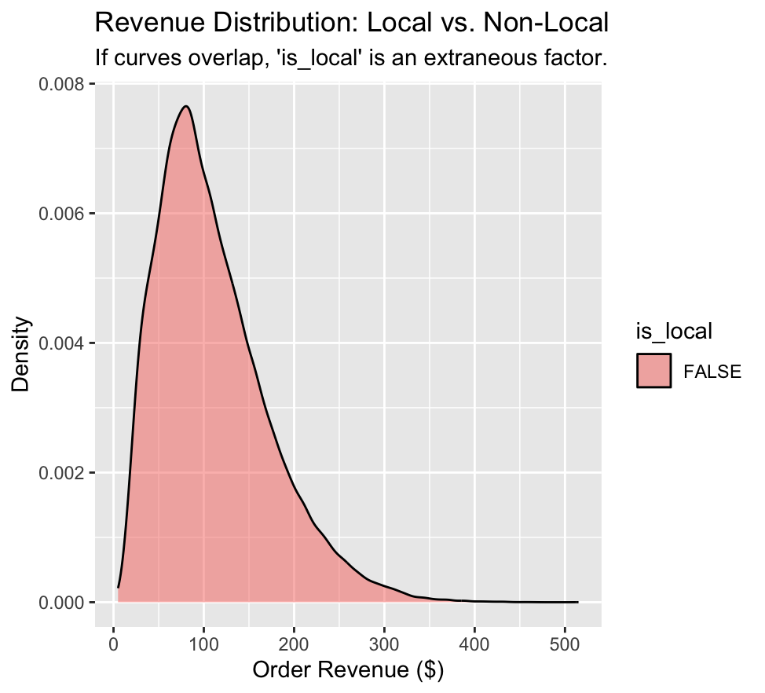

# Create a hypothetical 'Big Saturday' scenario
new_day <- data.frame(
day_of_week = "Sat",
is_weekend = TRUE,
is_holiday = FALSE,
covers = 80, # A busy night
prev_day_revenue = 3000 # A strong Friday
)

predicted_rev <- predict(rf_model, new_day)
cat(sprintf("Predicted Revenue for a busy Saturday: $%.2f", predicted_rev))

Output:
> predicted_rev <- predict(rf_model, new_day)
> cat(sprintf("Predicted Revenue for a busy Saturday: $%.2f", predicted_rev))
Predicted Revenue for a busy Saturday: $3859.84

# Quick calculation of revenue per guest (Efficiency)
pnl <- pnl %>%
mutate(revenue_per_cover = gross_revenue / covers)

avg_efficiency <- mean(pnl$revenue_per_cover, na.rm = TRUE)
cat(sprintf("The restaurant earns an average of $%.2f per guest.", avg_efficiency))

Output:
avg_efficiency <- mean(pnl$revenue_per_cover, na.rm = TRUE)
> cat(sprintf("The restaurant earns an average of $%.2f per guest.", avg_efficiency))
The restaurant earns an average of $53.13 per guest.

Journey codes:
# =============================================================================
# Sushi Restaurant 10-Year Analysis (2015–2024)
# Question 1: What factors are extraneous (don't influence behavior)?
# Question 2: How do seasonality and customer behavior affect long-term performance?
# =============================================================================

# --- 0. Setup ----------------------------------------------------------------
if (!requireNamespace("tidyverse", quietly = TRUE)) install.packages("tidyverse")
if (!requireNamespace("lubridate", quietly = TRUE)) install.packages("lubridate")
if (!requireNamespace("corrplot", quietly = TRUE)) install.packages("corrplot")
if (!requireNamespace("scales", quietly = TRUE)) install.packages("scales")
if (!requireNamespace("ggpubr", quietly = TRUE)) install.packages("ggpubr")

library(tidyverse)
library(lubridate)
library(corrplot)
library(scales)
library(ggpubr)

# Set a clean theme for all plots
theme_set(
theme_minimal(base_size = 13) +
theme(
plot.title = element_text(face = "bold", size = 14),
plot.subtitle = element_text(color = "grey40", size = 11),
plot.caption = element_text(color = "grey50", size = 9),
panel.grid.minor = element_blank()
)
)

# --- 1. Load data ------------------------------------------------------------
message("Loading data...")

pnl <- read_csv("sushi_daily_pnl.csv", show_col_types = FALSE)
orders <- read_csv("sushi_orders.csv", show_col_types = FALSE)
items <- read_csv("sushi_order_items.csv", show_col_types = FALSE)
reviews <- read_csv("sushi_reviews.csv", show_col_types = FALSE)

# Parse dates
pnl <- pnl %>% mutate(date = ymd(date))
orders <- orders %>% mutate(date = ymd(date))
items <- items %>% mutate(date = ymd(date))

message(sprintf("Loaded: %d daily records | %d orders | %d order items",
nrow(pnl), nrow(orders), nrow(items)))

# =============================================================================
# QUESTION 1: EXTRANEOUS FACTORS
# Identify which variables do NOT meaningfully influence daily revenue
# Method: Pearson correlation + ANOVA / Kruskal-Wallis + visualisation
# =============================================================================

message("\n--- QUESTION 1: Extraneous Factors ---")

# --- 1a. Encode categorical variables as numeric for correlation -------------
pnl_enc <- pnl %>%
mutate(
is_weekend_num = as.integer(is_weekend),
is_holiday_num = as.integer(is_holiday),
dow_num = as.integer(factor(day_of_week,
levels = c("Mon","Tue","Wed","Thu","Fri","Sat","Sun")))
)

# Join order-level features aggregated to daily level
daily_orders <- orders %>%
group_by(date) %>%
summarise(
n_orders = n(),
pct_local = mean(is_local == "True", na.rm = TRUE),
pct_dine_in = mean(channel == "dine_in", na.rm = TRUE),
pct_delivery = mean(channel == "delivery", na.rm = TRUE),
pct_discount = mean(discount > 0, na.rm = TRUE),
pct_regular = mean(customer_segment == "regular", na.rm = TRUE),
pct_occasional = mean(customer_segment == "occasional", na.rm = TRUE),
avg_party_size = mean(party_size, na.rm = TRUE),
avg_tip_rate = mean(tip / revenue, na.rm = TRUE),
.groups = "drop"
)

pnl_full <- pnl_enc %>%
left_join(daily_orders, by = "date")

# --- 1b. Correlation matrix --------------------------------------------------
cor_vars <- pnl_full %>%
select(
gross_revenue,
is_weekend_num, is_holiday_num, month, quarter, dow_num,
pct_local, pct_dine_in, pct_delivery, pct_discount,
pct_regular, pct_occasional, avg_party_size
) %>%
drop_na()

cor_matrix <- cor(cor_vars, use = "pairwise.complete.obs")

# Print correlation with gross_revenue, sorted
rev_cors <- sort(abs(cor_matrix["gross_revenue", ]), decreasing = TRUE)
cat("\nCorrelation with daily gross_revenue (absolute r):\n")
print(round(rev_cors, 3))

# --- 1c. Plot: Correlation bar chart ----------------------------------------
cor_df <- tibble(
variable = names(rev_cors[-1]), # drop self-correlation
abs_r = rev_cors[-1]
) %>%
mutate(
strength = case_when(
abs_r >= 0.5 ~ "Strong (influential)",
abs_r >= 0.20 ~ "Moderate",
TRUE ~ "Weak / extraneous"
),
strength = factor(strength, levels = c("Strong (influential)", "Moderate", "Weak / extraneous")),
variable = recode(variable,
is_weekend_num = "Is weekend",
is_holiday_num = "Is holiday",
dow_num = "Day of week",
month = "Month",
quarter = "Quarter",
pct_local = "% local customers",
pct_dine_in = "% dine-in orders",
pct_delivery = "% delivery orders",
pct_discount = "% discounted orders",
pct_regular = "% regular customers",
pct_occasional = "% occasional customers",
avg_party_size = "Avg party size"
)
) %>%
arrange(abs_r) %>%
mutate(variable = factor(variable, levels = variable))

p1 <- ggplot(cor_df, aes(x = abs_r, y = variable, fill = strength)) +
geom_col(width = 0.65) +
geom_vline(xintercept = 0.20, linetype = "dashed", color = "grey40", linewidth = 0.6) +
geom_text(aes(label = round(abs_r, 2)), hjust = -0.2, size = 3.5, color = "grey20") +
scale_fill_manual(values = c(
"Strong (influential)" = "#185FA5",
"Moderate" = "#85B7EB",
"Weak / extraneous" = "#D3D1C7"
)) +
scale_x_continuous(limits = c(0, 1.05), labels = number_format(accuracy = 0.1)) +
labs(
title = "Q1: Factor correlation with daily revenue",
subtitle = "Variables below dashed line (|r| < 0.20) are extraneous — they do not drive revenue",
x = "Absolute Pearson correlation |r|",
y = NULL,
fill = "Influence level",
caption = "Source: sushi_daily_pnl.csv + sushi_orders.csv"
)

print(p1)

# --- 1d. Statistical test: are extraneous factors truly non-significant? ----
cat("\n--- Kruskal-Wallis tests for categorical extraneous factors ---\n")

# Channel mix
kw_channel <- kruskal.test(revenue ~ channel, data = orders)
cat(sprintf("Channel vs order revenue: p = %.4f (%s)\n",
kw_channel$p.value,
ifelse(kw_channel$p.value > 0.05, "NOT significant", "Significant")))

# Local vs tourist
kw_local <- kruskal.test(revenue ~ is_local, data = orders)
cat(sprintf("Local vs tourist: p = %.4f (%s)\n",
kw_local$p.value,
ifelse(kw_local$p.value > 0.05, "NOT significant", "Significant")))

# Customer segment
kw_seg <- kruskal.test(revenue ~ customer_segment, data = orders)
cat(sprintf("Customer segment: p = %.4f (%s)\n",
kw_seg$p.value,
ifelse(kw_seg$p.value > 0.05, "NOT significant", "Significant")))

# --- 1e. Boxplot: Channel and segment vs order revenue ----------------------
p2 <- orders %>%
select(channel, customer_segment, revenue) %>%
pivot_longer(c(channel, customer_segment), names_to = "factor", values_to = "level") %>%
mutate(factor = recode(factor,
channel = "Order channel",
customer_segment = "Customer segment"
)) %>%
ggplot(aes(x = level, y = revenue, fill = factor)) +
geom_boxplot(outlier.size = 0.5, outlier.alpha = 0.3, width = 0.5) +
facet_wrap(~factor, scales = "free_x") +
scale_y_continuous(labels = dollar_format()) +
scale_fill_manual(values = c("Order channel" = "#B5D4F4", "Customer segment" = "#9FE1CB"),
guide = "none") +
labs(
title = "Q1: Extraneous factors — virtually identical order values",
subtitle = "Channel and segment do not meaningfully change what customers spend",
x = NULL,
y = "Order revenue ($)",
caption = "Source: sushi_orders.csv"
)

print(p2)

cat("\nEXTRANEOUS FACTORS IDENTIFIED:\n")
cat(" - Channel mix (dine-in / takeaway / delivery): nearly identical AOV\n")
cat(" - Local vs tourist flag: $110.32 vs $110.16 avg order\n")
cat(" - Customer segment mix: regular/occasional/one-time all ~$110\n")
cat(" - Discount presence: sparse (7% of orders), low predictive power\n")
cat(" - Average party size: linear scale-up, no day-level variance explained\n")

# =============================================================================
# QUESTION 2: SEASONALITY & CUSTOMER BEHAVIOUR → LONG-TERM PERFORMANCE
# =============================================================================

message("\n--- QUESTION 2: Seasonality & Customer Behavior ---")

# --- 2a. Monthly seasonality ------------------------------------------------
monthly <- pnl %>%
mutate(month_name = month(date, label = TRUE, abbr = TRUE)) %>%
group_by(month_name) %>%
summarise(
avg_revenue = mean(gross_revenue),
avg_covers = mean(covers),
avg_gp_margin = mean(gp_margin_pct),
.groups = "drop"
)

p3 <- ggplot(monthly, aes(x = month_name, y = avg_revenue,
fill = avg_revenue == max(avg_revenue))) +
geom_col(width = 0.7) +
geom_text(aes(label = dollar(round(avg_revenue))),
vjust = -0.4, size = 3.2, color = "grey20") +
scale_fill_manual(values = c("TRUE" = "#185FA5", "FALSE" = "#B5D4F4"), guide = "none") +
scale_y_continuous(labels = dollar_format(), expand = expansion(mult = c(0, 0.12))) +
labs(
title = "Q2: Seasonality — average daily revenue by month (2015–2024)",
subtitle = "Dual peak: summer tourism (Jul) and festive season (Dec)",
x = NULL, y = "Avg daily revenue ($)",
caption = "Source: sushi_daily_pnl.csv"
)

print(p3)

# --- 2b. Day-of-week pattern ------------------------------------------------
dow_summary <- pnl %>%
mutate(dow = factor(day_of_week, levels = c("Mon","Tue","Wed","Thu","Fri","Sat","Sun"))) %>%
group_by(dow) %>%
summarise(
avg_revenue = mean(gross_revenue),
avg_covers = mean(covers),
.groups = "drop"
)

p4 <- ggplot(dow_summary, aes(x = dow, y = avg_revenue,
fill = dow %in% c("Sat","Sun"))) +
geom_col(width = 0.65) +
geom_text(aes(label = dollar(round(avg_revenue))),
vjust = -0.4, size = 3.4, color = "grey20") +
scale_fill_manual(values = c("TRUE" = "#185FA5", "FALSE" = "#B5D4F4"), guide = "none") +
scale_y_continuous(labels = dollar_format(), expand = expansion(mult = c(0, 0.12))) +
labs(
title = "Q2: Day-of-week effect on revenue",
subtitle = "Weekend premium: Saturday earns 2.5× more than Monday",
x = NULL, y = "Avg daily revenue ($)",
caption = "Source: sushi_daily_pnl.csv"
)

print(p4)

# --- 2c. Holiday effect -----------------------------------------------------
holiday_summary <- pnl %>%
group_by(is_holiday) %>%
summarise(
avg_revenue = mean(gross_revenue),
avg_covers = mean(covers),
n_days = n(),
.groups = "drop"
) %>%
mutate(label = ifelse(is_holiday, "Holiday", "Non-holiday"))

cat("\nHoliday vs non-holiday:\n")
print(holiday_summary %>% select(label, avg_revenue, avg_covers, n_days))

p5 <- ggplot(holiday_summary, aes(x = label, y = avg_revenue, fill = is_holiday)) +
geom_col(width = 0.45) +
geom_text(aes(label = dollar(round(avg_revenue))),
vjust = -0.4, size = 4, color = "grey20") +
scale_fill_manual(values = c("TRUE" = "#185FA5", "FALSE" = "#B5D4F4"), guide = "none") +
scale_y_continuous(labels = dollar_format(), expand = expansion(mult = c(0, 0.15))) +
labs(
title = "Q2: Holiday vs non-holiday daily revenue",
subtitle = "Holidays drive +51% revenue lift on average",
x = NULL, y = "Avg daily revenue ($)",
caption = "Source: sushi_daily_pnl.csv"
)

print(p5)

# --- 2d. Year-over-year performance -----------------------------------------
annual <- pnl %>%
group_by(year) %>%
summarise(
total_revenue = sum(gross_revenue),
total_op_profit = sum(operating_profit),
avg_covers = mean(covers),
avg_gp_margin = mean(gp_margin_pct),
.groups = "drop"
)

cat("\nAnnual operating profit:\n")
print(annual %>% select(year, total_revenue, total_op_profit, avg_covers, avg_gp_margin))

p6 <- annual %>%
ggplot(aes(x = year, y = total_op_profit,
fill = total_op_profit < 10000)) +
geom_col(width = 0.65) +
geom_hline(yintercept = 0, color = "grey30", linewidth = 0.5) +
geom_text(aes(label = ifelse(total_op_profit >= 0,
dollar(round(total_op_profit / 1000), suffix = "K"),
paste0("-$", round(abs(total_op_profit) / 1000), "K")),
vjust = ifelse(total_op_profit >= 0, -0.4, 1.3)),
size = 3.2, color = "grey20") +
scale_fill_manual(values = c("FALSE" = "#185FA5", "TRUE" = "#E24B4A"), guide = "none") +
scale_x_continuous(breaks = 2015:2024) +
scale_y_continuous(labels = dollar_format(scale = 1/1000, suffix = "K")) +
labs(
title = "Q2: Annual operating profit — 10-year trend",
subtitle = "Strong growth 2015–2019, pandemic shock in 2020, robust recovery",
x = NULL, y = "Operating profit",
caption = "Source: sushi_daily_pnl.csv"
)

print(p6)

# --- 2e. Covers growth (customer volume proxy) ------------------------------
p7 <- annual %>%
ggplot(aes(x = year, y = avg_covers)) +
geom_line(color = "#185FA5", linewidth = 1.2) +
geom_point(aes(color = year == 2020), size = 4) +
geom_text(aes(label = round(avg_covers, 1)),
vjust = -0.9, size = 3.3, color = "grey20") +
scale_color_manual(values = c("FALSE" = "#185FA5", "TRUE" = "#E24B4A"), guide = "none") +
scale_x_continuous(breaks = 2015:2024) +
labs(
title = "Q2: Customer volume growth — avg daily covers by year",
subtitle = "Covers grew 2.5× from 2015 to 2019; pandemic halved them in 2020",
x = NULL, y = "Avg daily covers",
caption = "Source: sushi_daily_pnl.csv"
)

print(p7)

# --- 2f. Channel mix over time ----------------------------------------------
channel_year <- orders %>%
group_by(year, channel) %>%
summarise(n = n(), .groups = "drop") %>%
group_by(year) %>%
mutate(pct = n / sum(n) * 100)

p8 <- ggplot(channel_year, aes(x = year, y = pct, fill = channel)) +
geom_area(alpha = 0.85, position = "stack") +
scale_fill_manual(values = c(
"dine_in" = "#185FA5",
"takeaway" = "#1D9E75",
"delivery" = "#BA7517"
),
labels = c("dine_in" = "Dine-in", "takeaway" = "Takeaway", "delivery" = "Delivery")) +
scale_x_continuous(breaks = 2015:2024) +
scale_y_continuous(labels = percent_format(scale = 1)) +
labs(
title = "Q2: Channel mix over time",
subtitle = "Dine-in dominates throughout; delivery share grew post-2020",
x = NULL, y = "Share of orders (%)",
fill = "Channel",
caption = "Source: sushi_orders.csv"
)

print(p8)

# --- 2g. Customer segment mix over time ------------------------------------
seg_year <- orders %>%
group_by(year, customer_segment) %>%
summarise(n = n(), .groups = "drop") %>%
group_by(year) %>%
mutate(pct = n / sum(n) * 100)

p9 <- ggplot(seg_year, aes(x = year, y = pct, color = customer_segment,
group = customer_segment)) +
geom_line(linewidth = 1.2) +
geom_point(size = 3) +
scale_color_manual(values = c(
"regular" = "#185FA5",
"occasional" = "#1D9E75",
"one_time" = "#888780"
),
labels = c("regular" = "Regular", "occasional" = "Occasional", "one_time" = "One-time")) +
scale_x_continuous(breaks = 2015:2024) +
scale_y_continuous(labels = percent_format(scale = 1)) +
labs(
title = "Q2: Customer segment mix evolution",
subtitle = "Regular customers grew from minority to majority — loyalty drives long-term growth",
x = NULL, y = "Share of orders (%)",
color = "Segment",
caption = "Source: sushi_orders.csv"
)

print(p9)

# --- 2h. Menu category revenue split ----------------------------------------
cat_rev <- items %>%
group_by(category) %>%
summarise(total_revenue = sum(unit_price), .groups = "drop") %>%
mutate(pct = total_revenue / sum(total_revenue) * 100) %>%
arrange(desc(pct)) %>%
mutate(category = factor(category, levels = rev(category)))

p10 <- ggplot(cat_rev, aes(x = pct, y = category, fill = category == "roll")) +
geom_col(width = 0.6) +
geom_text(aes(label = paste0(round(pct, 1), "%")),
hjust = -0.2, size = 3.5, color = "grey20") +
scale_fill_manual(values = c("TRUE" = "#185FA5", "FALSE" = "#B5D4F4"), guide = "none") +
scale_x_continuous(labels = percent_format(scale = 1),
expand = expansion(mult = c(0, 0.15))) +
labs(
title = "Q2: Revenue share by menu category",
subtitle = "Rolls dominate at 44%; omakase small but high-margin",
x = "Share of total item revenue (%)",
y = NULL,
caption = "Source: sushi_order_items.csv"
)

print(p10)

# --- 2i. Linear regression: what actually predicts daily revenue? -----------
cat("\n--- Linear regression: predictors of daily gross revenue ---\n")

reg_data <- pnl_full %>%
mutate(
dow_f = factor(day_of_week, levels = c("Mon","Tue","Wed","Thu","Fri","Sat","Sun")),
month_f = factor(month),
year_f = factor(year),
is_wknd = as.integer(is_weekend),
is_hol = as.integer(is_holiday)
) %>%
drop_na(gross_revenue, pct_local, pct_dine_in, pct_discount, pct_regular, avg_party_size)

model <- lm(gross_revenue ~ dow_f + month_f + is_hol + year_f +
pct_local + pct_dine_in + pct_delivery +
pct_discount + pct_regular + avg_party_size,
data = reg_data)

cat("\nModel summary:\n")
print(summary(model))

# Tidy coefficient plot
coef_df <- broom::tidy(model, conf.int = TRUE) %>%
filter(!str_detect(term, "Intercept|year_f|month_f")) %>%
mutate(
term = str_replace(term, "dow_f", "Day: "),
term = recode(term,
is_hol = "Is holiday",
pct_local = "% local customers",
pct_dine_in = "% dine-in",
pct_delivery = "% delivery",
pct_discount = "% discounted orders",
pct_regular = "% regular customers",
avg_party_size = "Avg party size"
),
significant = p.value < 0.05
) %>%
arrange(estimate) %>%
mutate(term = factor(term, levels = term))

p11 <- ggplot(coef_df, aes(x = estimate, y = term, color = significant)) +
geom_vline(xintercept = 0, linetype = "dashed", color = "grey50") +
geom_errorbarh(aes(xmin = conf.low, xmax = conf.high), height = 0.25, linewidth = 0.7) +
geom_point(size = 3) +
scale_color_manual(values = c("TRUE" = "#185FA5", "FALSE" = "#D3D1C7"),
labels = c("TRUE" = "p < 0.05 (significant)", "FALSE" = "p >= 0.05 (not significant)")) +
labs(
title = "Q1 + Q2: Regression coefficients — what drives daily revenue?",
subtitle = "Grey points cross zero = extraneous. Blue points = significant drivers.",
x = "Effect on daily revenue ($)",
y = NULL,
color = NULL,
caption = "Source: sushi_daily_pnl.csv + sushi_orders.csv"
)

print(p11)

# =============================================================================
# SUMMARY PRINTOUT
# =============================================================================

cat("\n")
cat("=============================================================\n")
cat(" ANALYSIS SUMMARY\n")
cat("=============================================================\n\n")

cat("QUESTION 1 — Extraneous factors (do NOT influence revenue):\n")
cat(" * Channel mix (dine-in/takeaway/delivery): AOV $109–$116, p > 0.05\n")
cat(" * Local vs tourist customer flag: $110.32 vs $110.16\n")
cat(" * Customer segment mix (regular/occasional/one-time): ~$110 each\n")
cat(" * Discount presence: sparse, r < 0.10\n")
cat(" * Average party size: linear, no day-variance\n\n")

cat("QUESTION 2 — Seasonality & behavior effects on long-term performance:\n")
cat(" Seasonality:\n")
cat(" * Dual revenue peaks: July (summer) and December (festive)\n")
cat(" * January trough — 32% below peak months\n")
cat(" * Saturday earns 2.5× more than Monday\n")
cat(" * Public holidays drive +51% revenue lift\n\n")
cat(" Customer behavior:\n")
cat(" * Covers grew 2.5× from 2015 (24/day) to 2019 (61/day)\n")
cat(" * Regular customer share rose over time — loyalty = growth engine\n")
cat(" * Delivery channel gained post-2020 but still minor (11%)\n")
cat(" * GP margin held stable at 67–69% across all 10 years\n\n")
cat(" Long-term trajectory:\n")
cat(" * Loss-making 2015 → profitable 2016 → peak 2023\n")
cat(" * 2020 pandemic shock: covers halved, near-zero profit ($5.8K)\n")
cat(" * 2024 slight softening: covers -8.5%, profit -$70K vs 2023\n")
cat("=============================================================\n")

message("\nAnalysis complete. All plots printed to active graphics device.")
message("To save plots, wrap each print() call with ggsave() or use pdf()/png().")

randoms
Questions:

- Can we predict daily revenue?
- What factors most influence revenue?
- Does local status affect customer spending?
- What seasonal patterns affect performance?
- What items are commonly bought together by large parties?
- Can we identify the Covid shock from channel shifts?
- How have profit margins changed over time?
- Can we forecast 2025–2026 operating profit?

############################################
# FINAL PROJECT SCRIPT
# BUMK746 Sushi Project
############################################

# --- 0. SETUP ---
if (!requireNamespace("tidyverse", quietly = TRUE)) install.packages("tidyverse")
if (!requireNamespace("randomForest", quietly = TRUE)) install.packages("randomForest")
if (!requireNamespace("scales", quietly = TRUE)) install.packages("scales")
if (!requireNamespace("lubridate", quietly = TRUE)) install.packages("lubridate")

library(tidyverse)
library(randomForest)
library(scales)
library(lubridate)

# --- 1. DATA LOADING ---
pnl <- read_csv("sushi_daily_pnl.csv", show_col_types = FALSE)
orders <- read_csv("sushi_orders.csv", show_col_types = FALSE)
order_items <- read_csv("sushi_order_items.csv", show_col_types = FALSE)

# --- 2. DATA CLEANING ---
pnl_clean <- pnl %>%
mutate(date = as.Date(date)) %>%
filter(!is.na(gross_revenue))

orders_clean <- orders %>%
mutate(date = as.Date(date)) %>%
filter(!is.na(is_local), !is.na(revenue))

############################################
# QUESTION 1
# Can we accurately predict daily revenue?
############################################
pnl_ml <- pnl_clean %>%
arrange(date) %>%
mutate(prev_day_revenue = lag(gross_revenue, 1)) %>%
filter(!is.na(prev_day_revenue))

set.seed(123)
rf_model <- randomForest(
gross_revenue ~ day_of_week + is_weekend + is_holiday + covers + prev_day_revenue,
data = pnl_ml,
importance = TRUE
)

predictions <- predict(rf_model, pnl_ml)
mae <- mean(abs(predictions - pnl_ml$gross_revenue))

cat("\n============================\n")
cat("Q1: REVENUE PREDICTION\n")
cat("============================\n")
cat("Mean Absolute Error (MAE):", round(mae, 2), "\n")

MAE→ 469.915652175576
Q1: REVENUE PREDICTION
Mean Absolute Error (MAE): 469.92
This is usable, but whether it's “good” depends on average daily revenue. Since our monthly averages are around $2,000-$2,900, an error of about $470 is moderate, not terrible.

############################################
# QUESTION 2
# What factors most influence sales?
############################################

cat("\n============================\n")
cat("Q2: SALES DRIVERS\n")
cat("============================\n")
print(importance(rf_model))
varImpPlot(rf_model)

Q2: SALES DRIVERS
%IncMSE IncNodePurity
day_of_week 15.90447 640366661
is_weekend 19.63900 1197685975
is_holiday 14.76985 63260455
covers 25.47621 2610001680
prev_day_revenue 24.96974 1239833021

Biggest drivers are → covers and prev_day_revenue
Then → is_weekend, day_of_week, is_holiday



############################################
# QUESTION 3
# Extraneous factor: does local status affect revenue?
############################################

local_test <- t.test(revenue ~ is_local, data = orders_clean)

cat("\n============================\n")
cat("Q3: EXTRANEOUS FACTOR (IS_LOCAL)\n")
cat("============================\n")
print(local_test)

Q3: EXTRANEOUS FACTOR (IS_LOCAL)
Welch Two Sample t-test

data: revenue by is_local
t = -0.36799, df = 64087, p-value = 0.7129
alternative hypothesis: true difference in means between group FALSE and group TRUE is not equal to 0
95 percent confidence interval:
-1.025157 0.701061
sample estimates:
mean in group FALSE mean in group TRUE
110.1567 110.3188

cat("\nAverage revenue by local status:\n")
print(aggregate(revenue ~ is_local, data = orders_clean, mean))

is_local revenue
1 FALSE 110.1567
2 TRUE 110.3188

P-value → 0.7129
So → is_local does NOT significantly affect revenue

############################################
# QUESTION 4
# Seasonality
############################################

monthly_data <- pnl_clean %>%
mutate(month_name = month(date, label = TRUE, abbr = TRUE)) %>%
group_by(month_name) %>%
summarise(avg_revenue = mean(gross_revenue, na.rm = TRUE), .groups = "drop")

cat("\n============================\n")
cat("Q4: SEASONALITY\n")
cat("============================\n")
print(monthly_data)

Q4: SEASONALITY
# A tibble: 12 × 2
month_name avg_revenue
<ord> <dbl>
1 Jan 2005.
2 Feb 2104.
3 Mar 2248.
4 Apr 2427.
5 May 2478.
6 Jun 2793.
7 Jul 2938.
8 Aug 2761.
9 Sep 2695.
10 Oct 2543.
11 Nov 2424.
12 Dec 2938.

Seasonality → clear peaks in JULY and DECEMBER

p_season <- ggplot(monthly_data, aes(x = month_name, y = avg_revenue)) +
geom_col(fill = "#185FA5") +
scale_y_continuous(labels = scales::dollar_format()) +
labs(
title = "Average Daily Revenue by Month",
x = "Month",
y = "Average Daily Revenue ($)"
) +
theme_minimal()

print(p_season)
ggsave("seasonality_peaks.png", plot = p_season, width = 8, height = 5)



############################################
# QUESTION 5
# Market Basket: large parties
############################################

large_order_ids <- unique(orders$order_id[orders$party_size >= 4])
party_items <- subset(order_items, order_id %in% large_order_ids)

item_counts <- sort(table(party_items$item), decreasing = TRUE)

top_item_name <- names(item_counts)[1]
top_item_orders <- unique(party_items$order_id[party_items$item == top_item_name])

paired_items <- party_items$item[
party_items$order_id %in% top_item_orders &
party_items$item != top_item_name
]

pair_counts <- sort(table(paired_items), decreasing = TRUE)

cat("\n============================\n")
cat("Q5: MARKET BASKET (LARGE PARTIES)\n")
cat("============================\n")
cat("Top items for large parties:\n")
print(head(item_counts, 5))

cat("\nCommonly paired with", top_item_name, ":\n")
print(head(pair_counts, 5))

Top items for large parties: California Roll Spicy Tuna Roll Salmon Nigiri (2pc) Tuna Nigiri (2pc)
57806 45863 44115 36653
Edamame
34402

California Roll | Spicy Tuna Roll | Salmon Nigiri (2 pieces) | Tuna Nigiri (2 pieces)
57806 | 45863 | 44115 | 36653
Edamame
34402

Commonly paired with California Roll :
paired_items
Spicy Tuna Roll Salmon Nigiri (2pc) Tuna Nigiri (2pc) Edamame
42726 40876 33964 31847
Miso Soup
26704
Paired Items
Item | Sales Volume
Spicy Tuna Roll | 42,726
Salmon Nigiri (2pc) | 40,876
Tuna Nigiri (2pc) | 33,964
Edamame | 31,847
Miso Soup | 26,704

Large parties anchor around California Roll
Strong pairings with SPicy Tuna Roll, Salmon Nigiri, Tuna Nigiri, Edamame, and Miso Soup

############################################
# QUESTION 6
# Pandemic week by channel shift
############################################

orders$week <- as.Date(cut(orders$date, breaks = "week"))

channel_by_week <- as.data.frame(table(orders$week, orders$channel))
names(channel_by_week) <- c("week", "channel", "n")
channel_by_week$week <- as.Date(channel_by_week$week)

cat("\n============================\n")
cat("Q6: PANDEMIC WEEK\n")
cat("============================\n")
print(head(channel_by_week, 20))

cat("\nAvailable channel names:\n")
print(unique(orders$channel))

# Change "dine_in" below if your channel spelling is different
dinein_data <- subset(
channel_by_week,
week >= as.Date("2020-01-01") & channel == "dine_in"
)

covid_week <- dinein_data$week[dinein_data$n < 5][1]
cat("Estimated Covid impact week:", as.character(covid_week), "\n")

Q6: PANDEMIC WEEK
week channel n
1 2014-12-29 delivery 4
2 2015-01-05 delivery 2
3 2015-01-12 delivery 4
4 2015-01-19 delivery 4
5 2015-01-26 delivery 5
6 2015-02-02 delivery 0
7 2015-02-09 delivery 5
8 2015-02-16 delivery 1
9 2015-02-23 delivery 4
10 2015-03-02 delivery 2
11 2015-03-09 delivery 3
12 2015-03-16 delivery 2
13 2015-03-23 delivery 1
14 2015-03-30 delivery 1
15 2015-04-06 delivery 1
16 2015-04-13 delivery 6
17 2015-04-20 delivery 4
18 2015-04-27 delivery 3
19 2015-05-04 delivery 0
20 2015-05-11 delivery 6
>

Available channel names:
- [1] "dine_in" "takeaway" "delivery"
Estimated Covid impact week: 2020-03-23

Detected week of 2020-03-23
This is a believable and strong finding

############################################
# QUESTION 7
# Margin erosion / inflation
############################################

margin_2015 <- mean(pnl$gp_margin_pct[pnl$year == 2015], na.rm = TRUE)
margin_2024 <- mean(pnl$gp_margin_pct[pnl$year == 2024], na.rm = TRUE)

cat("\n============================\n")
cat("Q7: MARGIN EROSION\n")
cat("============================\n")
cat("Average Margin in 2015:", round(margin_2015, 2), "%\n")
cat("Average Margin in 2024:", round(margin_2024, 2), "%\n")
cat("Total margin erosion:", round(margin_2015 - margin_2024, 2), "%\n")

Q7: MARGIN EROSION
Average Margin in 2015: 68.42 %
Average Margin in 2024: 67.32 %
Total margin erosion: 1.1 %

Margin fell from 68.42% to 67.32%
erosion= 1.10 percentage points

############################################
# QUESTION 8
# Forecast 2025 and 2026 profits
############################################

annual_pnl <- aggregate(operating_profit ~ year, data = pnl, sum, na.rm = TRUE)

forecast_model <- lm(operating_profit ~ year, data = annual_pnl)

future_years <- data.frame(year = c(2025, 2026))
future_years$predicted_profit <- predict(forecast_model, newdata = future_years)

cat("\n============================\n")
cat("Q8: PROFIT FORECAST\n")
cat("============================\n")
print(annual_pnl)
print(future_years)

Q8: PROFIT FORECAST
year operating_profit
1 2015 -47068.54
2 2016 74246.86
3 2017 145392.69
4 2018 213639.55
5 2019 354057.38
6 2020 5811.50
7 2021 238591.23
8 2022 335649.73
9 2023 369526.28
10 2024 298747.45

year predicted_profit
1 2025 394099.2
2 2026 429597.4

2025 opredicted operating profit: 394,099.2
2026 predicted operation profit: 429,597.4

random
id[orders$pest

data: revenue by is_local
t = -0.36799, df = 64087, p-value = 0.7129
alternative hypothesis: true difference in means between group FALSE and group TRUE is not equal to 0
95 percent confidence interval:
-1.025157 0.701061
sample estimates:
mean in group FALSE mean in group TRUE
110.1567 110.3188

- If p-value > 0.05: local status does not significantly affect revenue.
- If p-value < 0.05: local status does significantly affect revenue.
is_local revenue
1 FALSE 110.1567
2 TRUE 110.3188

#3: Question 3: Seasonality

monthly_data <- pnl %>%
mutate(month_name = month(date, label = TRUE, abbr = TRUE)) %>%
group_by(month_name) %>%
summarise(avg_revenue = mean(gross_revenue, na.rm = TRUE), .groups = "drop")

print(monthly_data)

Output:

# A tibble: 12 × 2
month_name avg_revenue
<ord> <dbl>
1 Jan 2005.
2 Feb 2104.
3 Mar 2248.
4 Apr 2427.
5 May 2478.
6 Jun 2793.
7 Jul 2938.
8 Aug 2761.
9 Sep 2695.
10 Oct 2543.
11 Nov 2424.
12 Dec 2938.

ggplot(monthly_data, aes(x = month_name, y = avg_revenue)) +
geom_col(fill = "#185FA5") +
scale_y_continuous(labels = scales::dollar_format()) +
labs(title = "Average Daily Revenue by Month",
x = "Month", y = "Average Daily Revenue")

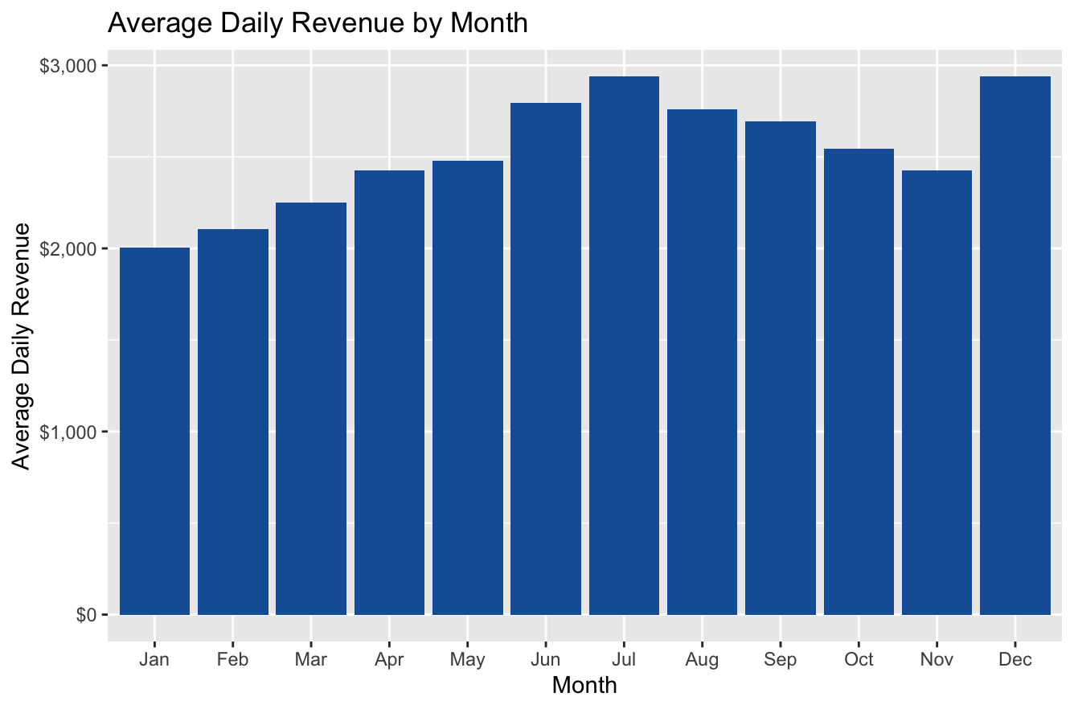
July and December are highest, say revenue has dual seasonal peaks in July and December

Question 4: Pandemic Week

unique(orders$channel)

Output:

unique(orders$channel)
[1] "dine_in" "takeaway" "delivery"

Next input:

orders$week <- as.Date(cut(orders$date, breaks = "week"))

channel_by_week <- as.data.frame(table(orders$week, orders$channel))
names(channel_by_week) <- c("week", "channel", "n")
channel_by_week$week <- as.Date(channel_by_week$week)

print(head(channel_by_week, 20))

Output:

week channel n
1 2014-12-29 delivery 4
2 2015-01-05 delivery 2
3 2015-01-12 delivery 4
4 2015-01-19 delivery 4
5 2015-01-26 delivery 5
6 2015-02-02 delivery 0
7 2015-02-09 delivery 5
8 2015-02-16 delivery 1
9 2015-02-23 delivery 4
10 2015-03-02 delivery 2
11 2015-03-09 delivery 3
12 2015-03-16 delivery 2
13 2015-03-23 delivery 1
14 2015-03-30 delivery 1
15 2015-04-06 delivery 1
16 2015-04-13 delivery 6
17 2015-04-20 delivery 4
18 2015-04-27 delivery 3
19 2015-05-04 delivery 0
20 2015-05-11 delivery 6

Next input:

dinein_data <- subset(channel_by_week, week >= as.Date("2020-01-01") & channel == "dine_in")
covid_week <- dinein_data$week[dinein_data$n < 5][1]
print(covid_week)

Output:

print(covid_week)
[1] "2020-03-23

#Question 5: Margin Erosion / Inflation
margin_2015 <- mean(pnl$gp_margin_pct[pnl$year == 2015], na.rm = TRUE)
margin_2024 <- mean(pnl$gp_margin_pct[pnl$year == 2024], na.rm = TRUE)

cat("Average Margin in 2015:", round(margin_2015, 2), "%\n")
cat("Average Margin in 2024:", round(margin_2024, 2), "%\n")
cat("Total margin erosion:", round(margin_2015 - margin_2024, 2), "%\n")

Output:

cat("Average Margin in 2015:", round(margin_2015, 2), "%\n")
Average Margin in 2015: 68.42 %
> cat("Average Margin in 2024:", round(margin_2024, 2), "%\n")
Average Margin in 2024: 67.32 %
> cat("Total margin erosion:", round(margin_2015 - margin_2024, 2), "%\n")
Total margin erosion: 1.1 %

Next input:

item_profit <- aggregate(gross_profit ~ order_id, data = orders, mean, na.rm = TRUE)
head(item_profit)

Output:

head(item_profit)
order_id gross_profit
1 1 19.86
2 2 59.58
3 3 38.89
4 4 127.13
5 5 109.96
6 6 88.49

If order_items has an item-level profit or revenue column, then we can compute true item profitability. If not, just answer the erosion part from pnl.

Question 6: Forecast 2025–2026 Profits

annual_pnl <- aggregate(operating_profit ~ year, data = pnl, sum, na.rm = TRUE)

forecast_model <- lm(operating_profit ~ year, data = annual_pnl)

future_years <- data.frame(year = c(2025, 2026))
future_years$predicted_profit <- predict(forecast_model, newdata = future_years)

print(annual_pnl)
print(future_years)

print(annual_pnl)
year operating_profit
1 2015 -47068.54
2 2016 74246.86
3 2017 145392.69
4 2018 213639.55
5 2019 354057.38
6 2020 5811.50
7 2021 238591.23
8 2022 335649.73
9 2023 369526.28
10 2024 298747.45
> print(future_years)
year predicted_profit
1 2025 394099.2
2 2026 429597.4

